A use case is “represents the steps in a specific business function or process.” (Shelly,RosenBlatt, 2012). A use case uses an external entity or actor to portray how the system will be used by the user. Use cases provides tools for capturing functional requirements as well as providing a starting point for identification of data objects or entries. The use case for a customer withdrawing money from the ATM service will require several steps in order to reach the completion. The use case actor in this particular use case will be the customer. This will describe the process in which the actor (customer) will use his/her ATM card to withdraw money from the ATM. This process with include the customer entering their ATM card into the ATM machine and withdrawing money from the bank. Successful completion of this use case will include the customer correctly entering their card and pin number, withdrawing the correct amount of cash, the bank transferring the cash to the customer, and the customer’s account being debited the amount of cash that is being withdrawn from the ATM machine. The precondition is that the customer’s ATM card must be correctly matched with the pin number for that card in order to proceed with the withdrawal. The post condition is that the customer’s account must be updated with a debit of the cash withdrawn from the ATM machine. There are no assumptions in this use case because several factors must be met including the correct entry of the pin number as well

Use Cases CIS 210 November 13, 2015 Name of Use Case: ATM Cash Withdrawal Primary Actor: Bank Customer Secondary Actor: Financial Institution Description: This use case begins when the customer needs to withdrawal funds from their bank account and the bank is closed. The customer goes to an ATM inserts their bank card. The customer has to have correct PIN to be able to access their account. Selects the type of account that the funds are to be withdrawn from and the amount. Precondition: Customer decides the amount they need to withdrawal. They determine the account that the funds will be available in to withdrawal. Typical Course: 1. Customer inserts bank card into ATM and inputs PIN number 2. Financial institution validates 3. ATM prompts for transaction choice 4. Customer selects withdrawal transaction 5. ATM prompts for account type 6. Customer select account to withdrawal from 7. ATM prompts for amount 8. Customer inputs amount and confirms 9. ATM dispenses cash Alternative Course: 1. Customer inserts bank card into ATM and inputs PIN number. 2. Financial institution validates 3. Customer selects to withdrawal funds from account 4. Financial institution rejects due to insufficient funds Postcondition: ATM customer’s bank account is debited the amount that was withdrawn by the customer Name of Use Case: ATM Account Deposit Primary Actor: Bank Customer Secondary Actor: Financial Institution Description: This use case begins when the customer needs to deposit funds into their bank account after the financial institution is closed. The customer goes to an ATM in order to make a deposit into their account. The customer has to access their account in order to be able to deposit a check or cash into their selected account. Precondition: Customer chooses which account to deposit money into through the ATM. Typical Course: 1. Customer inserts bank card into ATM and inputs PIN number 2. Bank verifies correct account 3. ATM prompts for transaction choice 4. Customer selects deposit 5. ATM prompts for account type to deposit 6. Customer selects account type 7. ATM prompts for amount 8. Customer input amount to deposit 9. Bank accepts transaction 10. Customer deposits cash/check 11. ATM dispenses receipt for deposit Alternative Course: 1. Customer inserts bank card into ATM and inputs PIN number. 2. Invalid PIN Number alert shows on the screen and says try again 3. Customer presses clear button and inputs the PIN number again. 4. Option to input PIN again with warning if the customer puts in the wrong PIN one more time they will lose access to the account. 5. Customer gets a failed transaction alert and card is retrieved by ATM Postcondition: ATM customer’s bank account is credited for the amount that was deposited once verified by the financial institution. Name of Use Case: ATM Account Transfer Primary Actor: Bank Customer Secondary Actor: Financial Institution Description: This use case begins when the customer needs to transfer funds from one bank account into another after the financial institution is closed. The customer goes to an ATM in order to transfer the funds from one account into another. The customer has to have sufficient funds in their account in order to be able to transfer the funds from selected account into another. Precondition: Customer chooses which account to transfer funds from and the amount and what account it will be transferred into using the ATM. Typical Course: 1. Customer inserts bank card into ATM and inputs PIN number 2. Bank verifies correct PIN number 3. ATM prompts for transaction choice 4. Customer selects transfer funds 5. ATM prompts for account type to transfer from and the amount 6. Customer selects account type and inputs amount 7. Financial institution verifies available amount in selected account funds are to be transferred from 8. ATM prompts for account to transfer funds into 9. Bank accepts transaction 10. ATM dispenses receipt of transaction Alternative Course: 1. Customer inserts bank card into ATM and inputs PIN number. 2. Bank verifies correct PIN number 3. ATM prompts for transaction choice 4. Customer selects transfer funds 5. ATM prompts for account type to transfer from and the amount 6. Customer selects account type and inputs amount 7. Financial institution verifies available amount is not in selected account and transaction is denied. Postcondition: ATM transfers funds from selected account into another bank account selected by the customer There is an ethical issue in connection with the use of an ATM system when it comes to depositing funds through and ATM. The customer may input a dollar amount of the deposit and it may not be the amount that has been deposited during the transaction. In addition, customers may deposit checks from another person’s accounts fraudulently into their account through the ATM system. References Rosenblatt, H.J. (2014) Systems Analysis and Design, Tenth Edition. (pp 235-238). Boston: Course Technology. Rosenberg, G, & Stephens, M (2007), Use Case Driven Object Modeling with UML: Theory and Practice. New York: Springer-Verlag Vonnegut, K. (2004-09). Use Cases – A Review, website: https://blackboard.strayer.edu/bbcswebdav/pid-17546298-dt-content-rid108740365_2/courses/CIS210008VA016-1158-001/Use%20Cases.pdf ...   
[View Full Document](https://www.coursehero.com/registerForm.php?reg_only=1&get_doc=14458615)

). After selection of the “to account,” the ATM prompts the customer for an amount,(TRANSFER AMOUNT), at which point the ATM transfers the money. Next the ATM produces receipt (PRODUCE RECEIPT) and subsequently ejects the customer’s card (EJECT CARD). Finally, the transaction is complete and the ATM closes the connection (CLOSECONNECTION).

**Transfer Alternative Flows**

When the ATM is validating the card type (VALIDATE TYPE), if the card is not recognized or is an invalid type, it prompts the customer to reinsert or insert a card that is compatible with the ATM’s network. The next possibility of error is during PIN entry, if wrong, the ATM prompts the customer for re-entry. Once selection of Transfer Amount (TRANSFERAMOUNT) is reached there are is the possibility of one error, the customer’s “From Account “doesn’t have the sufficient funds to be transferred, and notifies the costumer, and prompts the customer to enter a lower amount.

THE ATM USE CASE5

References

Heywood, R. (n.d.).UML Use Case Diagrams: Tips and FAQ. Retrieved from Carnegie Mellon University: https://www.andrew.cmu.edu/course/90-754/umlucdfaq.htmlVisual Paradigm. (2010).Writing Effective Use Case. Retrieved from Visual Paradigm for UML:http://www.visual-paradigm.com/product/vpuml/tutorials/writingeffectiveusecase.jspWilliams, L., Ho, D., & Smith, S. (2005).Use Case Diagrams. Retrieved from NC Stat

THE ATM USE CASE2

The ATM Use Case

A use case is a goal the customer wishes to achieve when accessing a system [Article]. When someone is at an ATM and wish to either withdraw, deposit or transfer money, there are several things that go on throughout the process that must work correctly, for if they do not, we would achieve undesirable results.

Preconditions

In order to utilize an ATM there are a few things or steps that must be true prior to use. The customer must have an ATM card, the ATM’s network must be connected to the customer’s bank and the customer’s ATM card must be accepted by the ATM.

Withdrawal Basic Flow

The customer inserts their card into the ATM, at this time the ATM verifies the card is valid and recognized card type to be used (VALIDATE TYPE), after which the machine prompts the customer for their Personal Identification Number, or PIN (VALIDATE PIN). Next, the customer selects Withdraw Funds (WITHDRAW FUNDS), the ATM then prompts the customer to select and account from which to withdraw (WITHDRAW ACCOUNT). After selection of the withdraw account the ATM prompts the customer for an amount, (WITHDRAW AMOUNT) then the ATM returns the customer’s card to them (EJECT CARD) prior to dispensing the funds to the customer and finally closes the connection (CLOSE CONNECTION) and the transaction is

Use Cases2

Use Cases for ATM Support

The following are the steps that are needed to begin the automated teller machine process, also included are the steps to make sure that process is successful.1.

1 Step One-Tasks to be completed

1.Identify actors

2.Identify actor goalsa. ATM Customer b.ATM Machinec.Customer withdraws moneyd. Customer checks account balance reads cardamom verifies customer and completes specific command1.

2- Use Case Description

1. Customer withdraws money from ATM The customer selects an ATM based on their preferences, inserts their card, and enters their pin. Once the customer is verified they select the exact amount of money they would like the machine to debit their account. Then they take their money and receipt

2.ATM Machine

The machine reads the customers card and presents the customer with the pin verification screen. The machine verifies the pin and gives the customer a list of options to choose from. The machine reads the selection of withdraw and asks the user what type of account they want to withdraw from. After the type of account is selected the ATM checks the account for sufficient funds, and dispenses the money along with a receipt. If the money is not there the machine tells customer there is insufficient funds.

Step by step process of withdrawing money by a customer from an ATM.

1.Customer inserts ATM card.

2.ATM reads card.

3.ATM shows pin prompt.

4.Customer enters pin.

5.ATM verifies us

ypical Case: ATM WithdrawalAn account holder arrives at the bank and walks up to an ATM. The account holder inserts theirbankcard into the ATM, and the machine reads the barcode information. The ATM determines thecard is valid for use and prompts the customer to enter their personal identification number. Theuser enters their personal identification number, and the ATM checks its database to make surethe number entered belongs to the card owners’ bank account. The ATM then presents thecustomer with transaction options. The customer selects withdraw. The ATM prompts the user toenter a dollar amount. The user enters the amount of cash they want to withdraw from theiraccount. The ATM validates the user’s account has enough available funds to process the requestand dispenses the cash. The user removes the cash from the ATM. The machine validateswhether the user would like to continue or end the transaction. The user selects no furthertransactions. The ATM prints out a receipt and returns the bankcard to the account hol

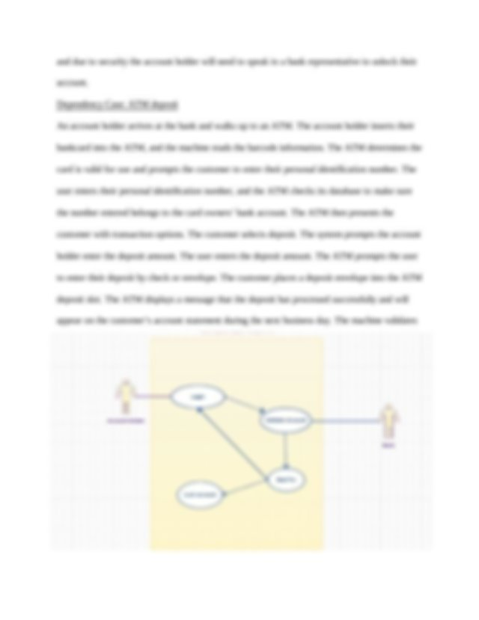

Alternative Case: Invalid PinAn account holder arrives at the bank and walks up to an ATM. The account holder inserts theirbankcard into the ATM, and the machine reads the barcode information. The ATM determines thecard is valid for use and prompts the customer to enter their personal identification number. Theuser enters their personal identification number, and the ATM checks its database to make surethe number entered belongs to the card owners’ bank account. The pin number entered do

No Confirmation: once prompted, if the Account Holder does not confirm the dollaramount the system will display a message for a new dollar amount. If the Account Holder doesnot respond this time, the system will cancel the transaction, exit the screen, and log out theAccount Holder.A print receipt will be an optional function provided to the Account Holder. The receiptwill display the current available balance.The receipt shall print after the ATM dispenses thecash and before offering other available service

Withdraw Funds Use CasesThis use case describes the withdrawal process between the Bank Account Holder and theATM to withdraw money from their bank account.•Withdrawal Approved•Withdrawal Failed Invalid PIN•Funds Not Availab

Withdrawal Approved ModuleThe Account Holder will have possession of the card and have already memorized theirPIN. As the Account Holder navigates through the ATM menus for withdrawal, they will need toenter an amount in $20.00 increments. The ATM will check if the amount requested in available

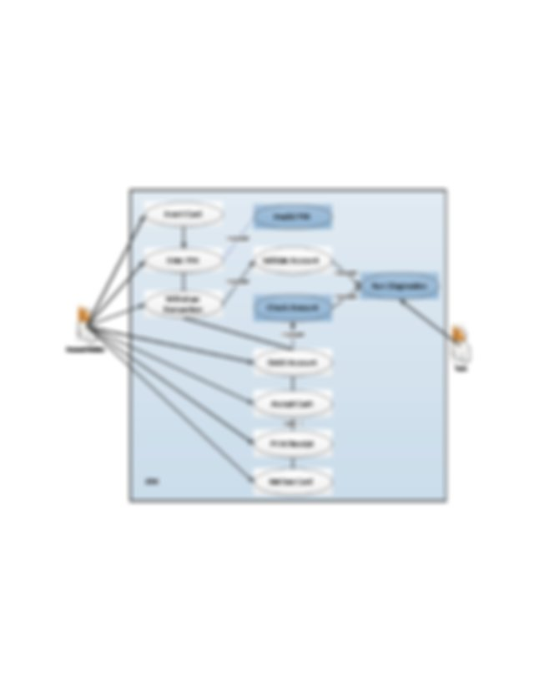

Use Cases to Support the ATM Service7

for withdrawal. The cash will be disbursed and account balance adjusted. The Account holderwill be prompted to take the cash. Once the cash is retrieved, the system will display a messagefor continuing with another transaction. When the operation is complete a Thank You messageshall display and remind the Account Holder to take their card.

Exceptions

Amount Exceeds Available Balance:

when the Account Holder requests a dollar amountgreater than they have available the system will display a message that the amount requested isnot available at this time. The Account Holder will be prompted to enter a different amount. Ifthe Account Holder does not respond the system will cancel the transaction, exit the screen, andlog the Account Holder out.In this use case are the basic or normal flow of events for Withdrawal Approved andconsists of the following:

1.The Account Holder places their card in the card slot.

2.The system prompts Account Holder for PIN.3.The Account Holder enters PIN.4.The system validates the card and PIN.5.The system prompts the user to select a transaction.6.The bank customer selects an account.7.The Account Holder selects Withdrawal.8.The system retrieves account information.9.The system prompts Account Holder for an amount to withdraw.10. The Account Holder enters the dollar amount.11. The system validates there is enough money in the account to support the withdrawal.12. The system checks there is sufficent cash in the machine to support the withdrawal.13. The system replies with a go-no-go reply telling if the transaction is ok.14. The system reduces the account by the dollar amount requested.15. The system dispenses money to the Account Holder.16. The system prompts Account Holder for receipt17. The Account Holder selects yes for a receip